6. Linear Optimal Control Theory for discrete time system

6.1 Introduction

* Terminology

What is Computer? … Engineers on computer introduced several terminologies. They are tricky.

I think the followings may be clear understandable. Given a signal whose mathematical description is defined as domain and range as you are familiar

* Domain:

Continuous time system: $x\left(t\right) , t∈R,$

Discrete time system: $x\left(t\right) , t∈N, integer space$

* Range:

Analog system: $x\left(t\right), x\left(t\right)∈ a continous function space .$

i.e., real number space

Discrete system: $x\left(t\right), x\left(t\right)∈a discrete function space$

i.e., rational number space

Digital system: $x\left(t\right), x\left(t\right)∈a digital valued function space$, i.e.

i.e., 2-digit space – {00,01,10,11}

3-digit space – {000,001,010,…,111}

Hey. You may not distinguish the words analog watches and digital watches. 50(?) years ago,

A Japanese company introduced a digital watch whose display is 8 – digit led, such as

11:01:55 🡪 11 o’clock 01 minute 55 second.

It is revolutionary to an analog watch. Hmm..

Nowadays computer is everywhere. Computer is a digital system. Digital system is a discrete system.

Discrete system is essential to every life. I think in UG, ASTU, you may already learn discrete /digital

control system. In this material, I hope, a summarize discrete control theorems. And remember we

are going to deal with a discrete -time system.,

$$x\left(n\right), x\left(k\right), x\left(nk\right)….$$

not a continuous-time system,

<https://en.wikipedia.org/wiki/Discretization>

6.2 Theory of Linear Discrete-time systems

There are two kinds of discrete systems as

1. Inherently discrete system: example 6.1
2. The discretized continuous system. Let’s a plant be a continuous time system. In order to discrete time controller, i.e., computer, there should be the same domain. So we need transformer as

* A transform of a discrete controller to a continuous one. So everything is a continuous time domain.
* A transform of a continuous system to a discrete one. So everything is a discrete time domain

Which one is better? Hmm…Case by case. However, nowadays in general, the transform of a

continuous time system to a discrete one, so that everything is a discrete time.

* Discretization a continuous time system with a zero-order holder and a sampler.

Let’s consider a general discrete time system block diagram as

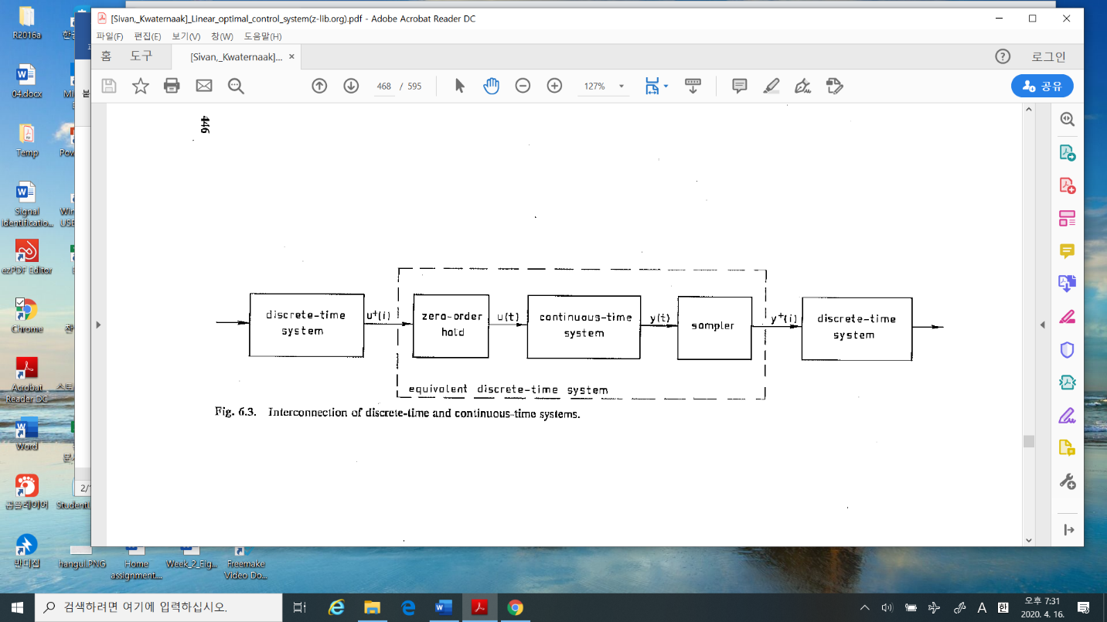

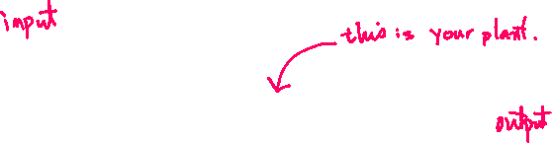

In this block, you have your continuous system, i.e., a servo motor. Now you are going to design a discrete controller using a computer. Let’s see the Fig.6.3. We may consider the system as

* Input: $u^{+}(i)$
* Output: $y^{+}(i)$

We are looking forward to the relation between the discrete input and the discrete output.

In the whole system, there are two kinds of time domain, one is discrete and the other is continuous.

Hence there should be **interfaces** between them. Those are zero order hold and sampler

Let’s see what they are

1. Zero- order hold (D/A digital to analog converter)

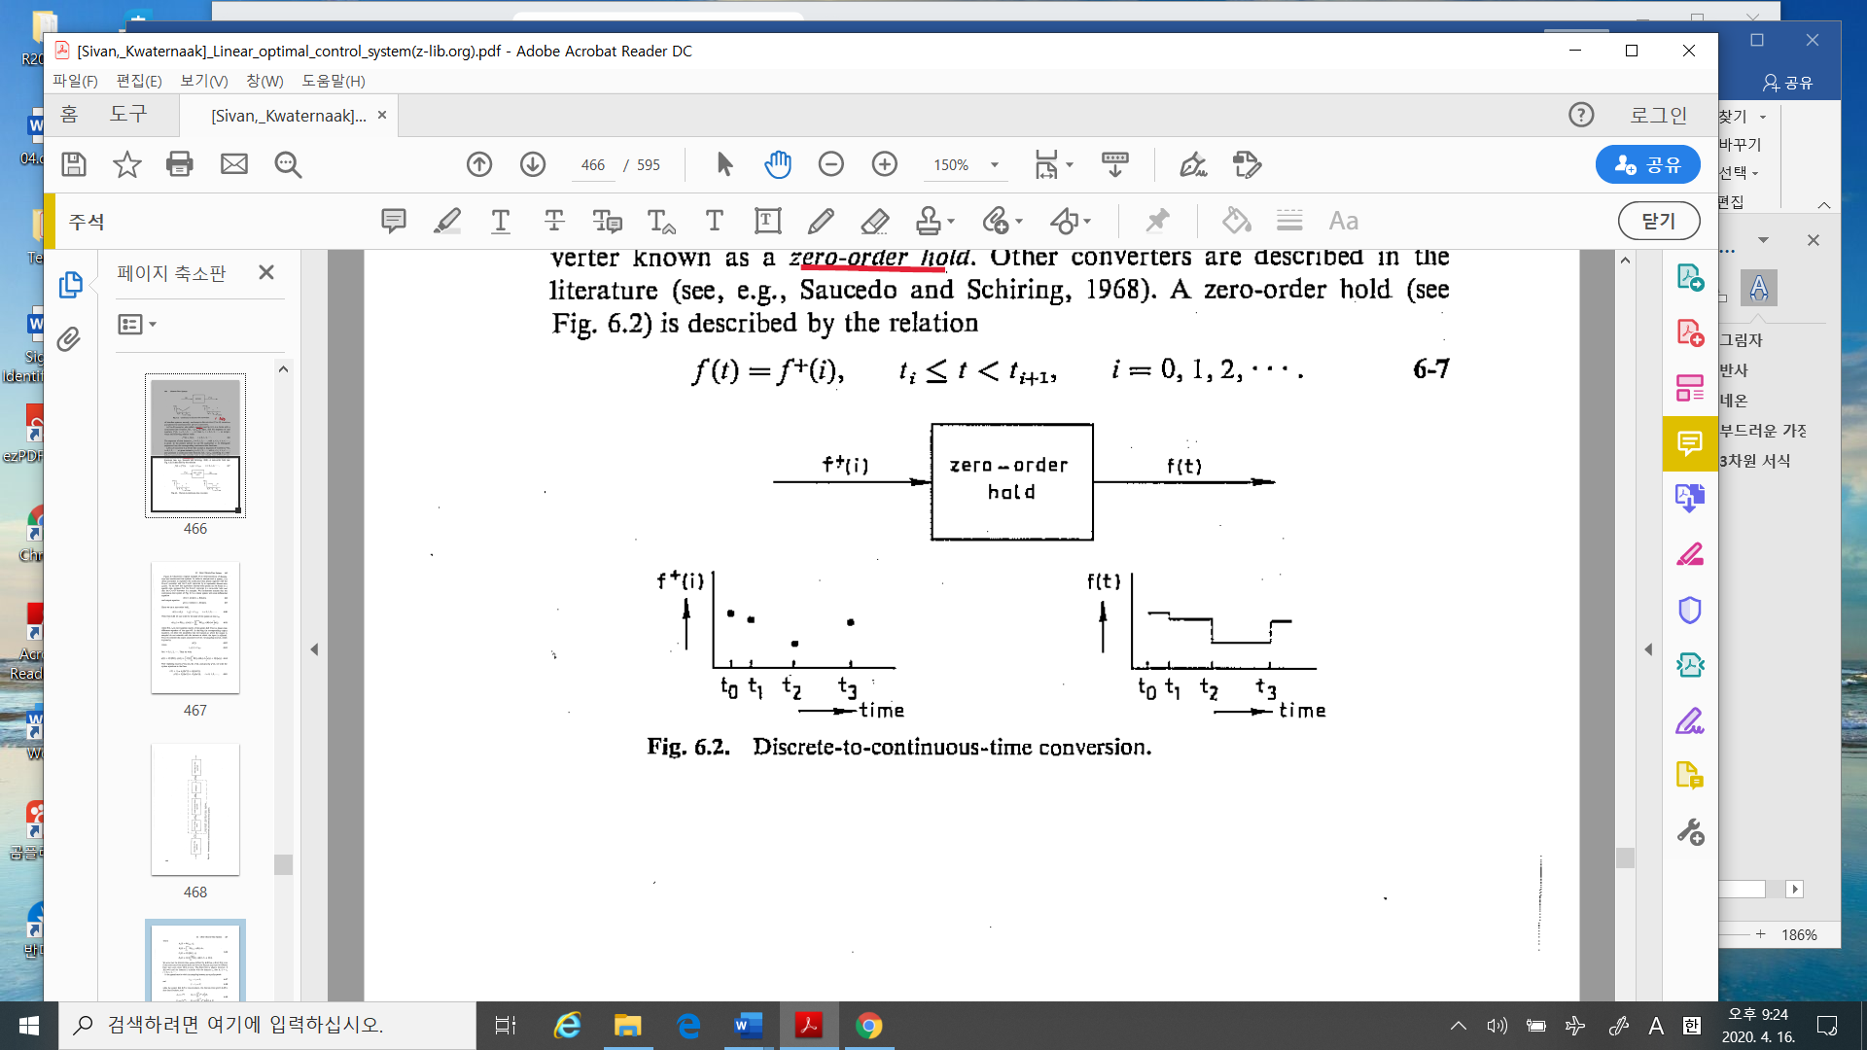

The mathematical description is (6 - 7). That is the input is a signal in a discrete time domain signal, i.e.,

During time $t_{i}≤ t<t_{i+1 }$

The input $f^{+}(i)$, which is a particular value,

The output $f(t)$ is a constant value as $f^{+}(i)$

The hardware is implemented approximately as

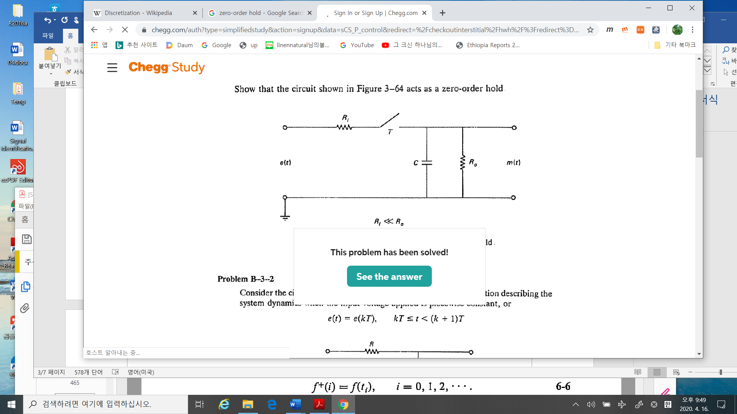

(Google: zero-order holder)

1. Sampler (A/D, analog to digital converter. “continuous to discrete time converter”)

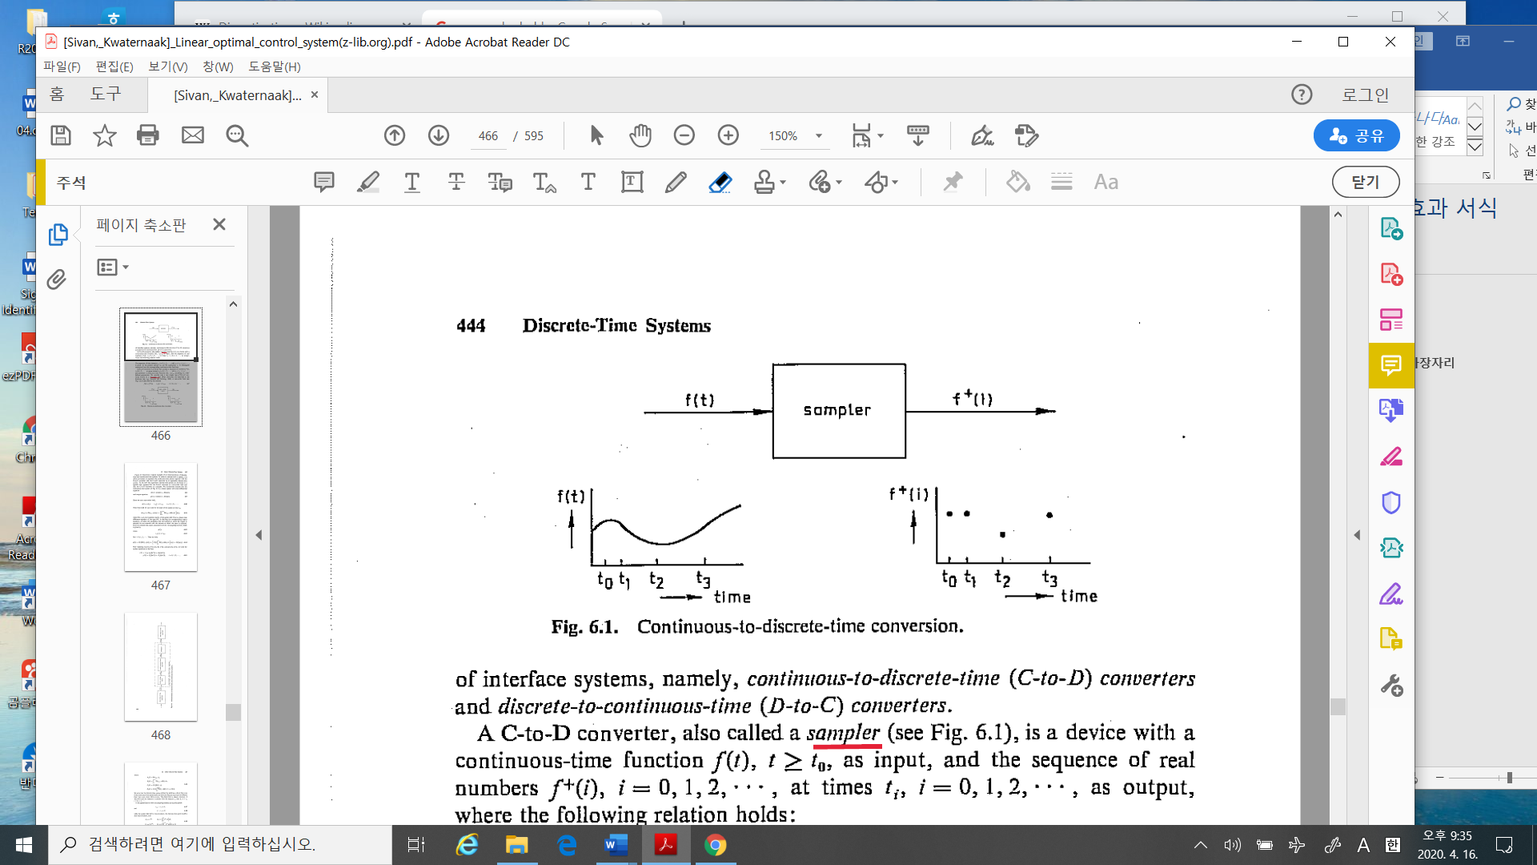

The model of sampler is

$$f^{+}\left(i\right)=f\left(t_{i}\right), i=1,2,3,…, t_{i-1 }<t_{i}<t_{i+1} (6-6)$$

The input $f(t_{i})$, which is a particular value of sampled f(t) at $t_{i}$

The output $f^{+}(i)$ is a discrete value

The hardware is implemented approximately as

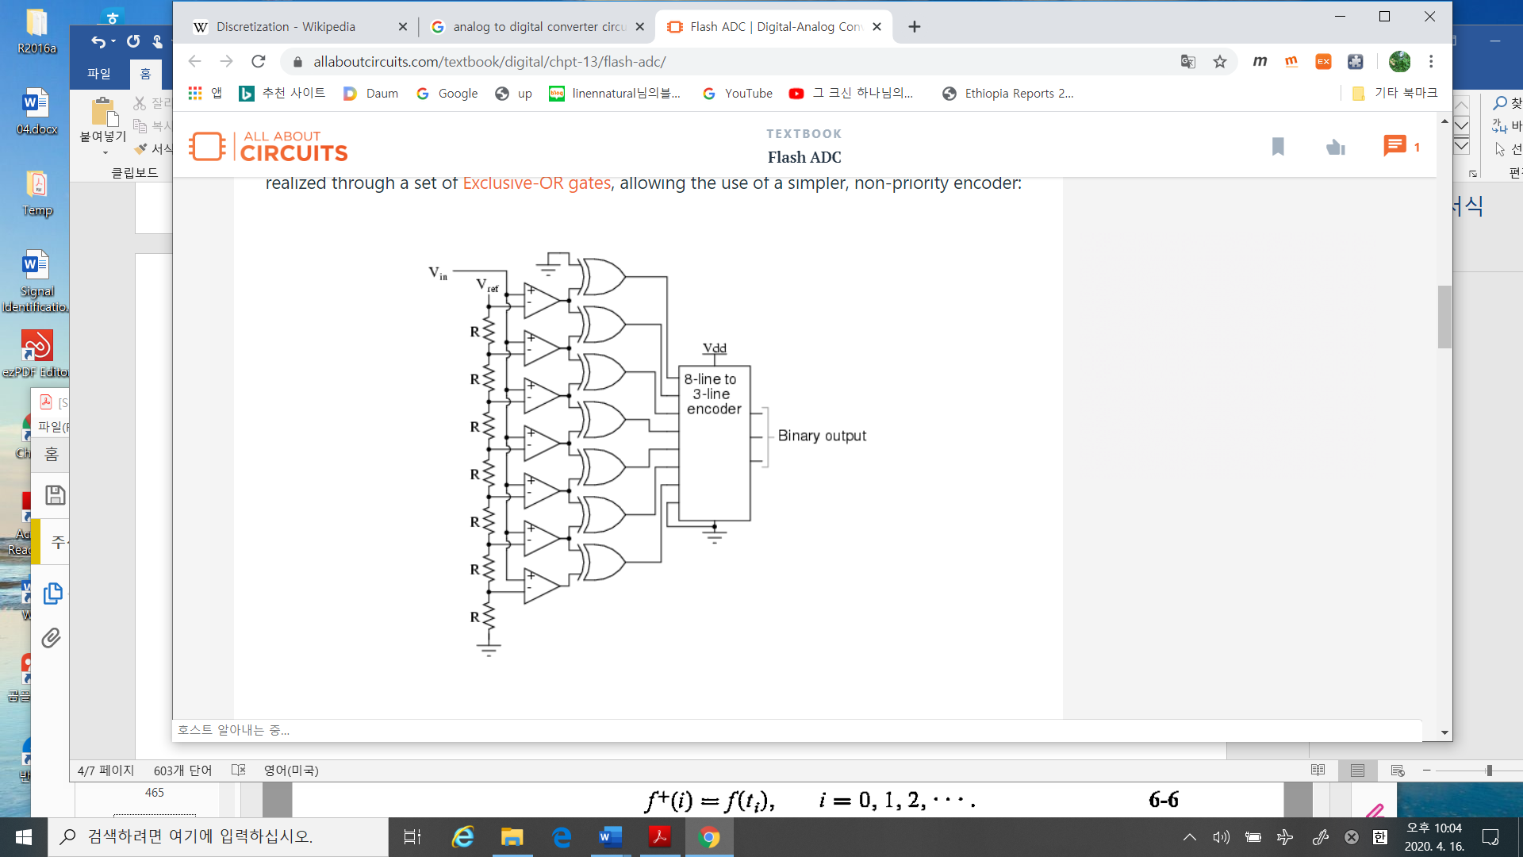

1. The discretization: for linear time invariant system
2. The exact solution

$\dot{x}= Ax+bu ∀ t∈R$

Then the solution is

$x\left(t\right)= e^{At} x\left(0\right)+ \int_{0}^{t}{e^{A\left(t-τ\right)}}Bu\left(τ\right)dτ (a.1)$

Define

$$x\left(t_{i}\right)=x\left(iT\right), T=the sampling time$$

Hence from (a.1)

$$x\left(t_{i}\right)=e^{AiT}x\left(0\right)+ \int_{0}^{iT}{e^{A\left(iT-τ\right)}Bu\left(τ\right)dτ}$$

At the next sampling time $t_{i+1}$

$$x\left(t_{i+1}\right)=e^{A(i+1)T}x\left(0\right)+ \int_{0}^{(i+1)T}{e^{A\left((i+1)T-τ\right)}Bu\left(τ\right)dτ} \\ =e^{AT}x\left(t_{i}\right)+A^{-1}\left(e^{AT}-I\right)Bu(t_{i}) \\ =A_{d}x\left(t_{i}\right)+B_{d}u(t_{i})$$

where

$$A_{d}=e^{AT}, B_{d}=A^{-1}\left(e^{AT}-I\right)B (a.2)$$

1. Approximation

Since

$$e^{AT}\sim I+AT, T≪1$$

Hence

$$x\left(t_{i+1}\right)=\left(I+AT\right)x\left(t_{i}\right)+TB u\left(t_{i}\right) (a.3)$$

%%%%%%%%%%%%%%---------comments

Given a continuous time system, the equivalent and one of the approximated solution is (a.2) and (a.3) respectively. The differences are based on the system matrix in the discrete system as

(a.2): $A_{d}=e^{AT}= I+AT+\frac{{\left(AT\right)}^{2}}{2}+,…$

(a.3): $A_{d}=1+AT$

Hence their eigenvalues are different. The other is the input matrix

(a.2): $B_{d}= A^{-1}\left(e^{AT}-I\right)B$

(a.3): $B_{d}=TB$

So By (a.2), to get $B_{d}$ the $A^{-1}$ must be calculated. Moreover the corresponding controllability matrix may have a different rank.

Should we use (a.2) rather than (a.3)? It depends on. Let’s see the following example.

----------------------------------------------%%%%%%%%%%%

* Digital positioning system(Example 2.4)

Let’s consider the continuous time system

$$\dot{x}= \left[\begin{matrix}0 & 1 \\ -1 & -α\end{matrix}\right]x+ \left[\begin{matrix}0 \\ κ\end{matrix}\right]u$$

I changed the system matrix as the e-values are all negative real.

$$α= 4.6, κ=0.787, Ts=0.1.$$

Then the discretization with a zero-order holder and sampler is derived using (a.2) and (a.3).

The continuous e-values = (-0.2288, -4.3712)

The (a.2) e-values = (0.9774, 0.6459)

The (a.3) e-values = (0.9771, 0.5629)

And with a initial point $x_{0}={\left(1,0\right)}^{'}$





Which one is better? It depends on, As you simulate results, looks Ok. In the

figure the blue one is the continuous, the red one is the exact discretization, the

last one is the approximated one.

%% example (6.2) : discretization example (6.2) using (a.2)

clear all;clc

a = 4.6;

k = 0.787;

Ts = 0.1;

A =[0 1; -1 -a];

B = [0 k]';

C = [1 0];

Ts = 0.1;

x0 = [ 1 0]';

% using (a.2) formula

I = eye(2);

A2 = expm(A*Ts);

A3 = I + A*Ts;

eig(A)

eig(A2)

eig(A3)

%%

figure

sys = ss(A,[ ],C,[ ]);

initial(sys,x0,'k'); grid on; hold on

%figure

sysd = ss(A2,[ ],C,[ ],Ts);

initial(sysd,x0,'r'); grid on

sysd3 = ss(A3,[ ],C,[ ],Ts);

initial(sysd3,x0,'b'); grid on

* Theorem 6.2: the solution of the discrete system9the difference equation)

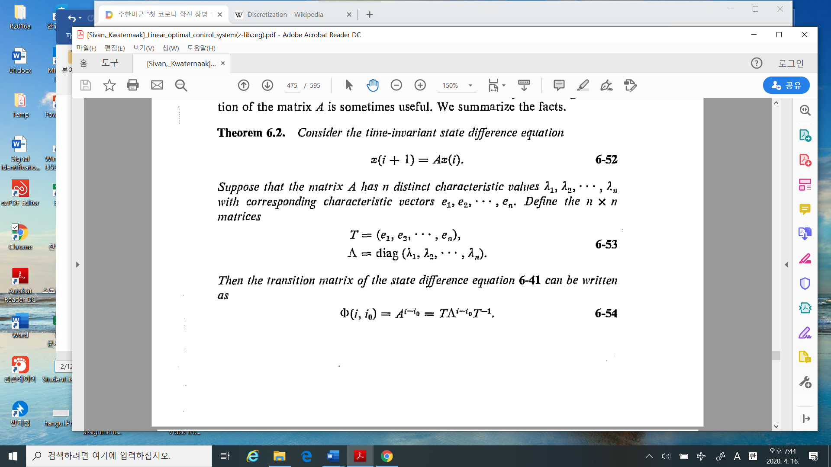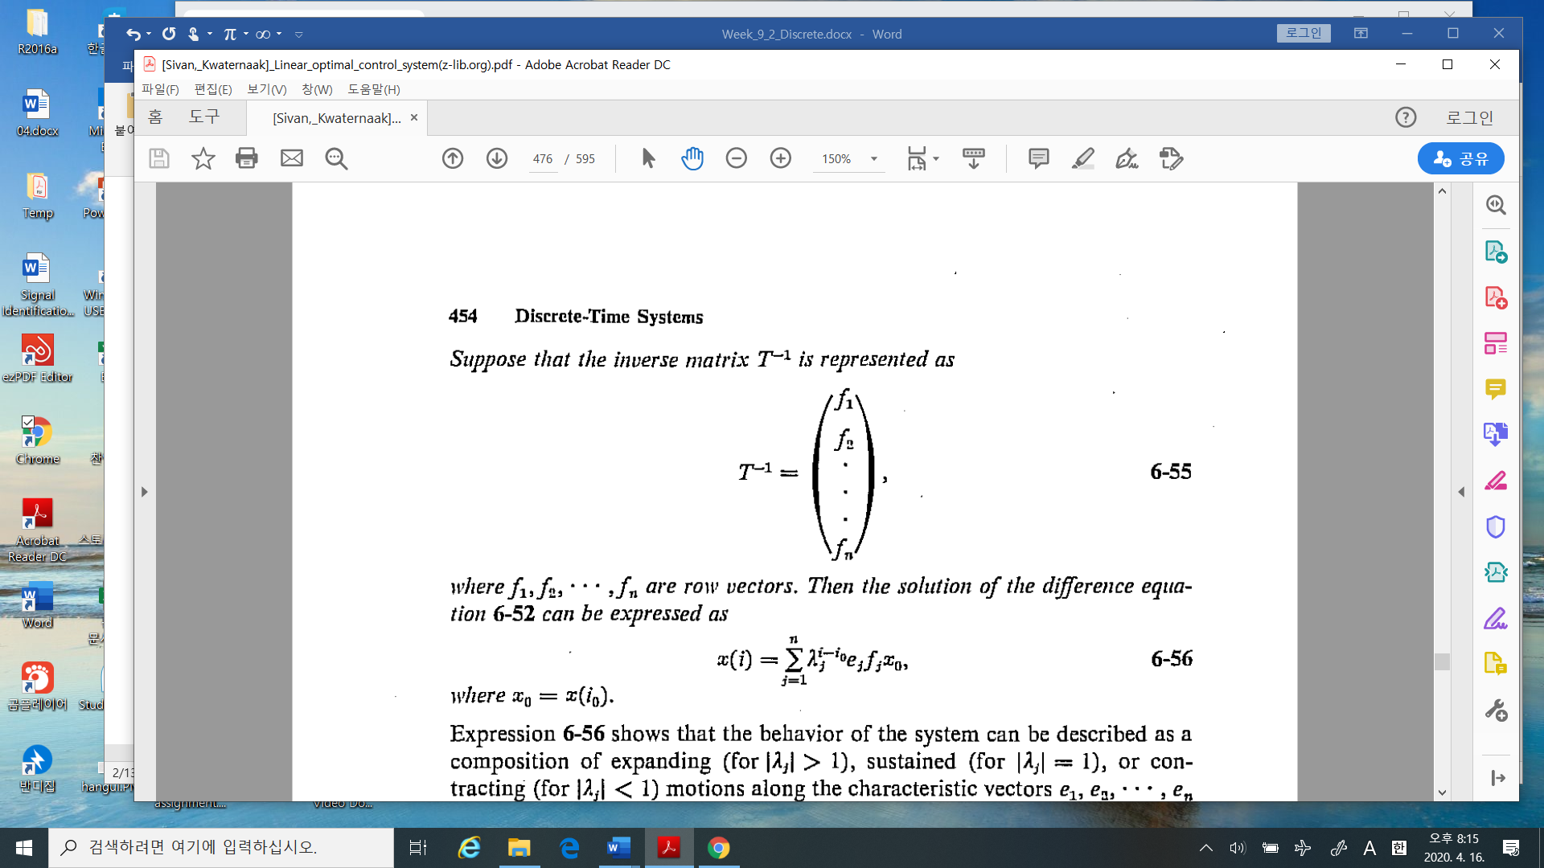

%%%%%%%%%%%%---------------- Week_2 – eigenvector , in linear algebra,

$$u_{k+1}=Au_{k} , u_{0}$$

Where the e-values and e-vctors satisfy these conditions

${Ax}_{i}=λ_{i}x_{i}, λ_{i} ≠λ_{j}, i≠j$

Then the solution of the above difference equation can be calculated as

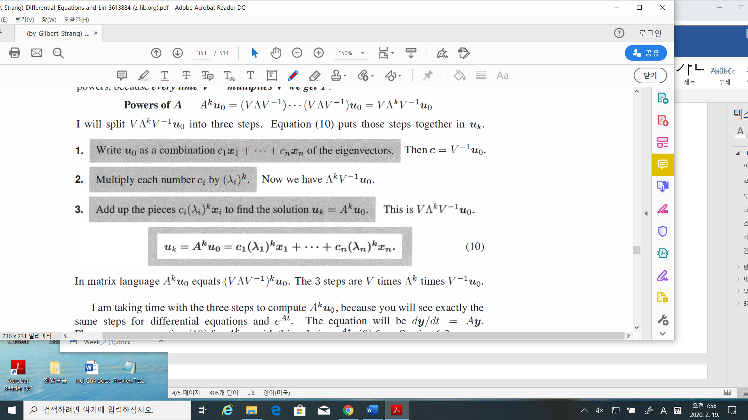

-----------------------------------------------------------%%%%%%%%%%%%%%

* Theorem 6.4: stability condition

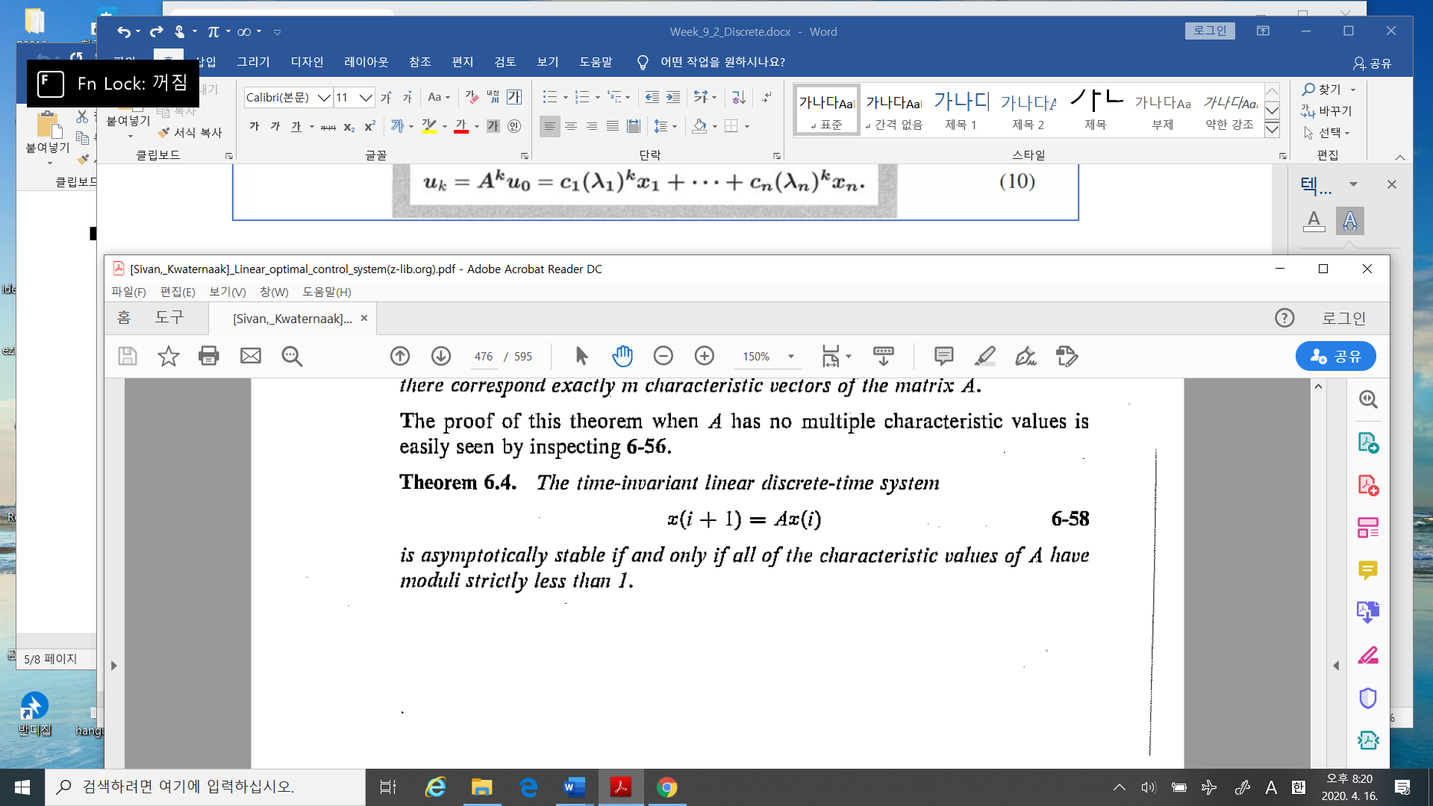

%%%%%%%%%-------- comments

Due to Theorem 6.2, it is proved sufficiently. As you may know, the stability condition on

discrete system compared to continuous time system (which is all e-values are negative real

parts) is

$\left|λ_{i}(A)\right|< 1 , ∀ i$

---------------------------------%%%%%%%%%%%%

* Theorem 6.6: controllability condition

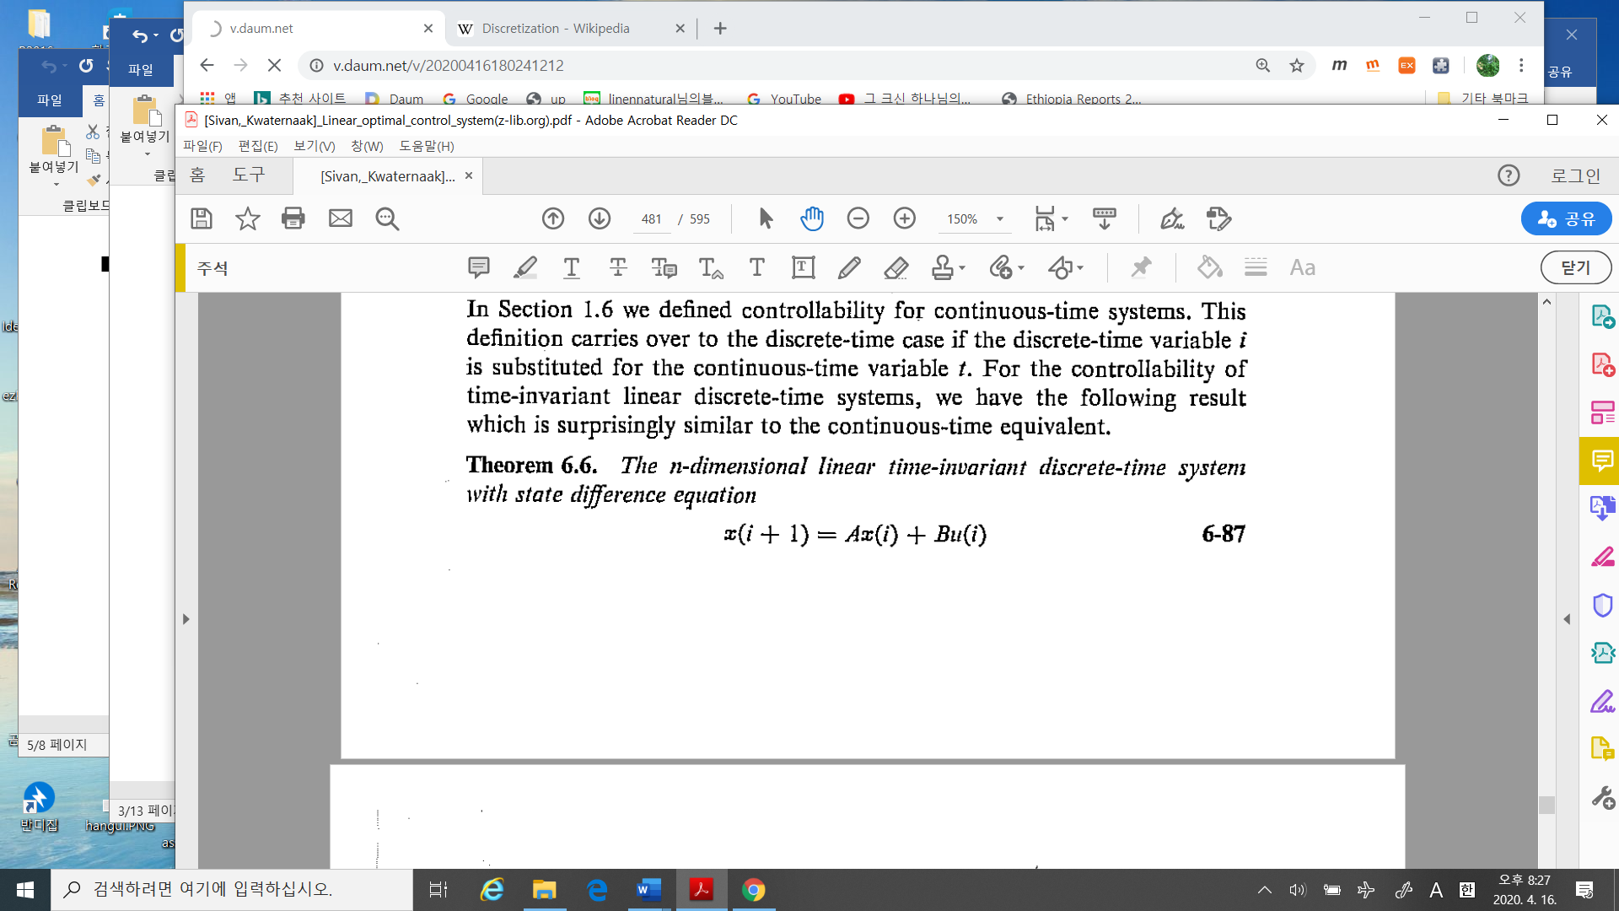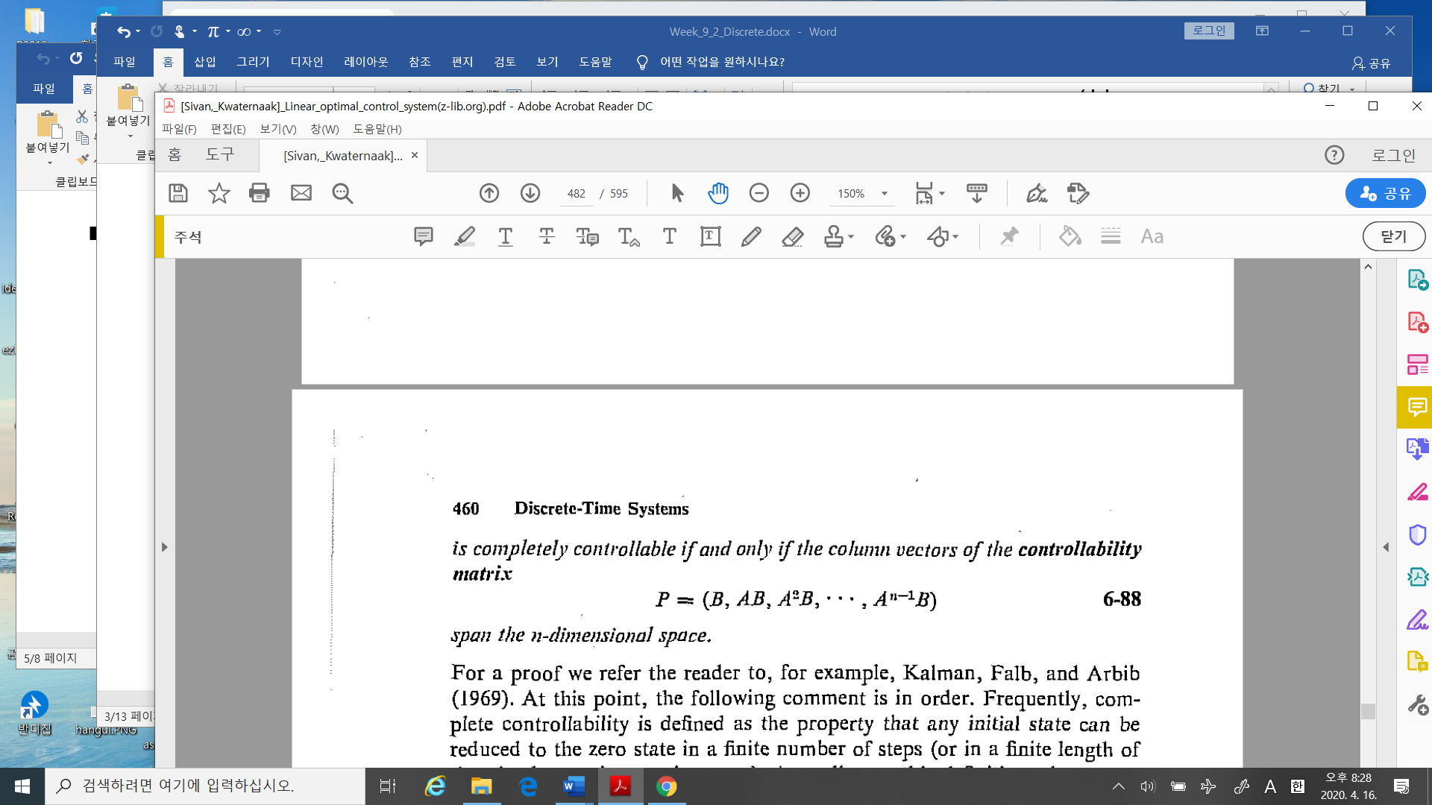

%%%%%%%%%%%%%%-----------comments

This is the same to the case of continuous system.

-------------------------------------%%%%%%%%%%%%%%%%%%%%%

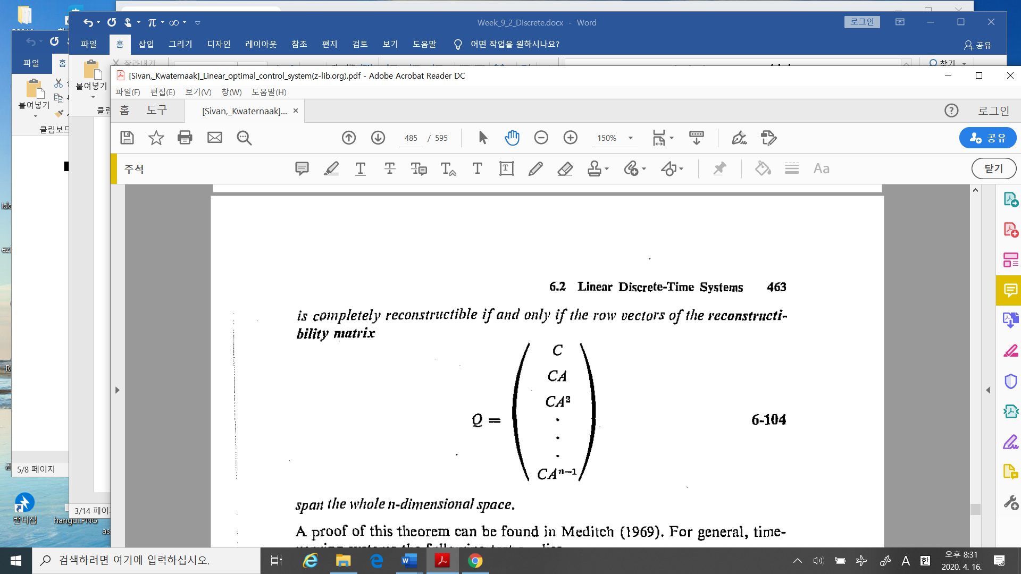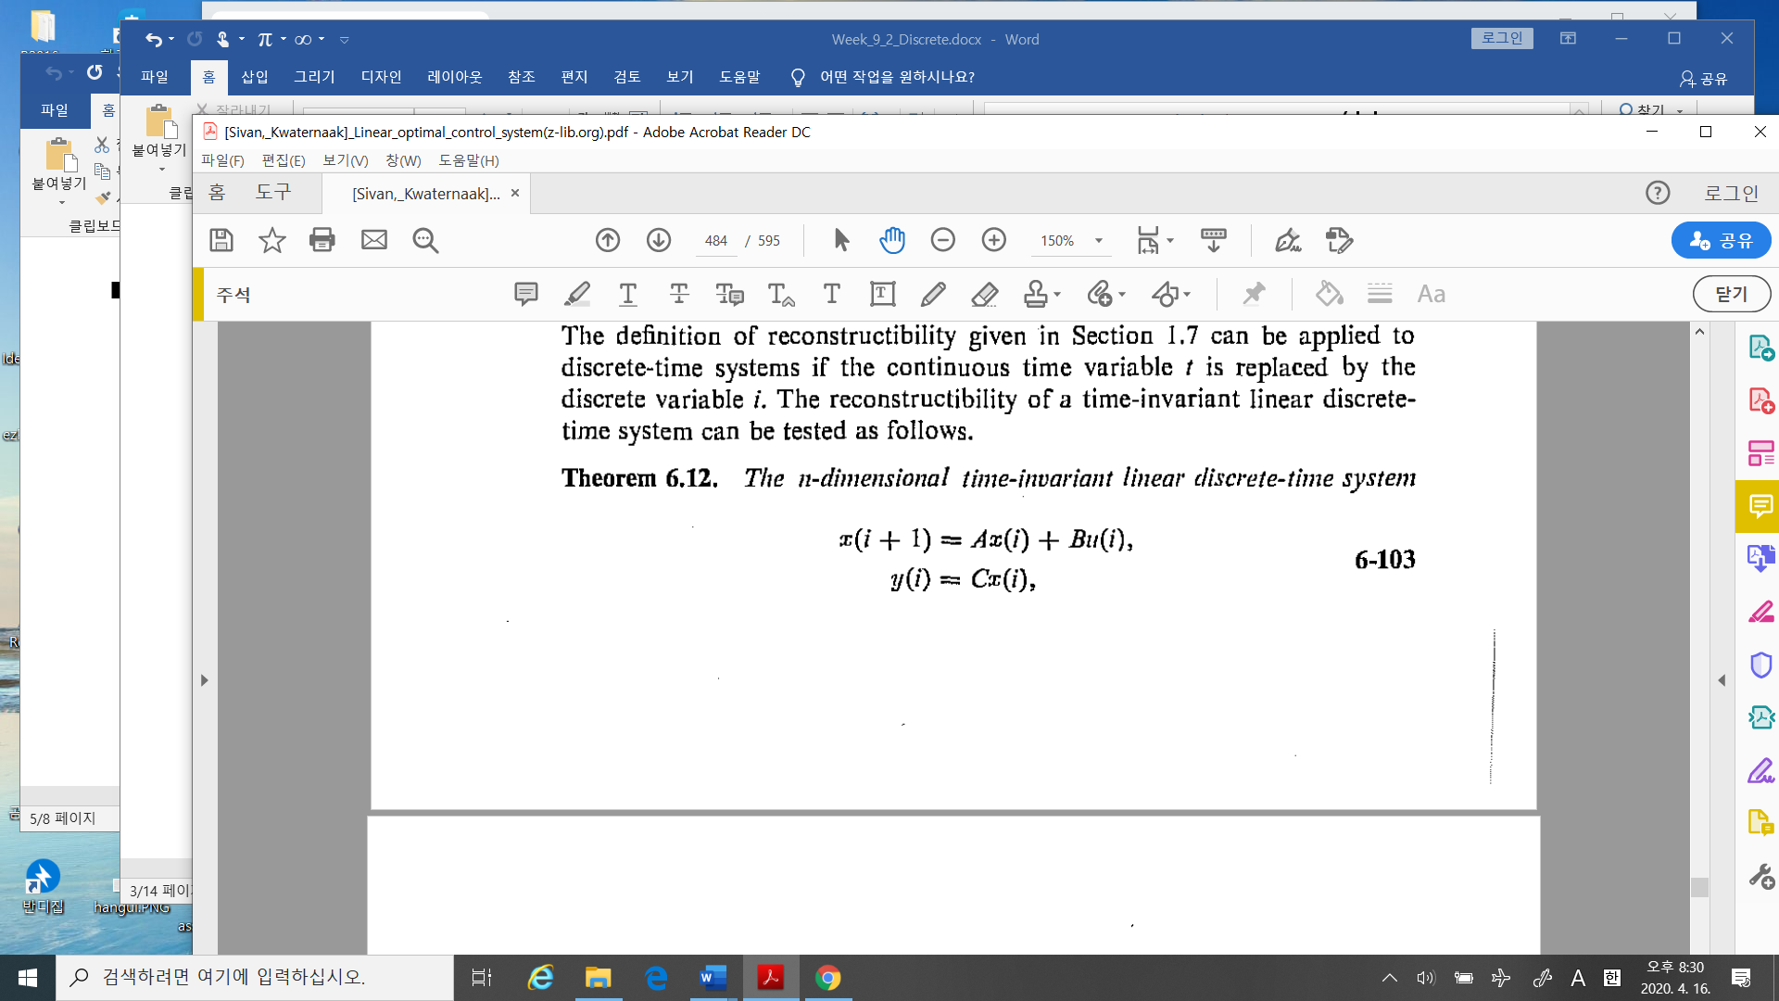

%%%%%%%%%%%%%%-----------comments

This is the same to the case of continuous system.

-------------------------------------%%%%%%%%%%%%%%%%%%%%%

* Theorem 6.22: In discrete stochastic linear system: mean and variance

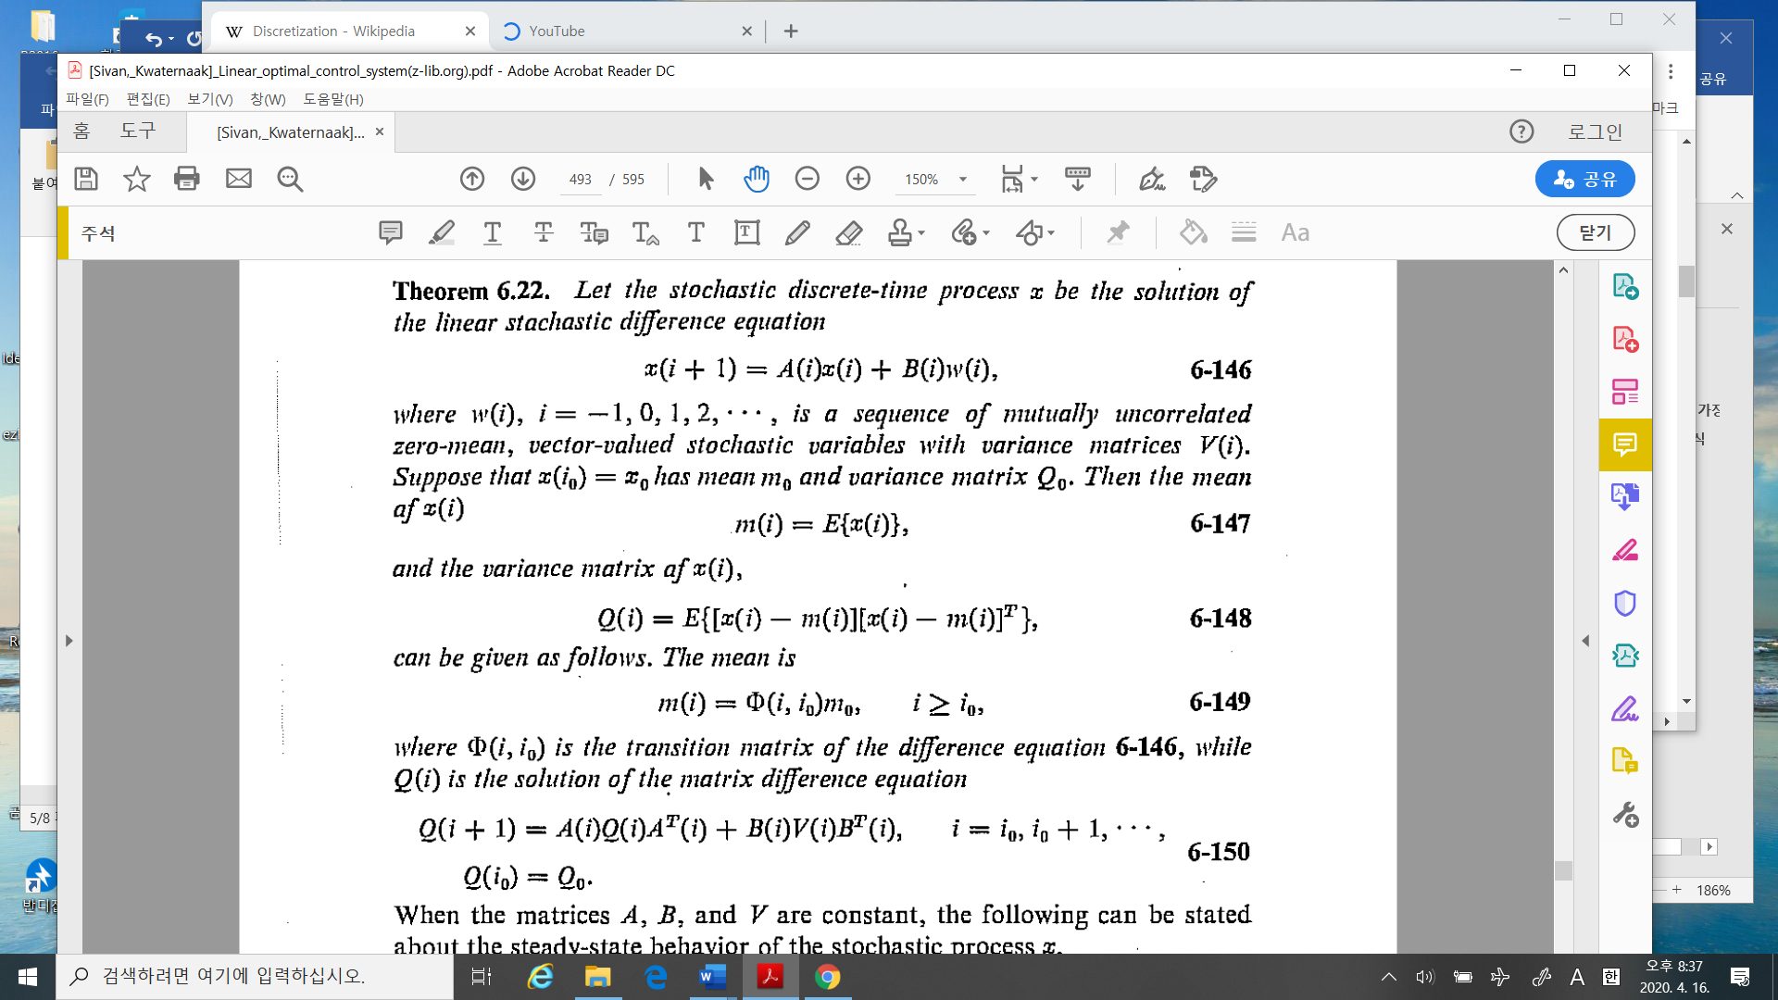



%%%%%%%%%%%------------- comments

In the continuous time case, i.e.,

$$\dot{x}=Ax+bw, E\left[ww^{T}\right]=V$$

Then the variance $Q\left(t\right)=E\left[\left[x\left(t\right)-m(t)\right]{\left[x\left(t\right)-m\left(t\right)\right]}^{T}\right]$ is calculated by

$\dot{Q}=AQ+QA^{T}+BVB^{T} (1-502)$

* Theorem 6.23: Steady state of mean and variance

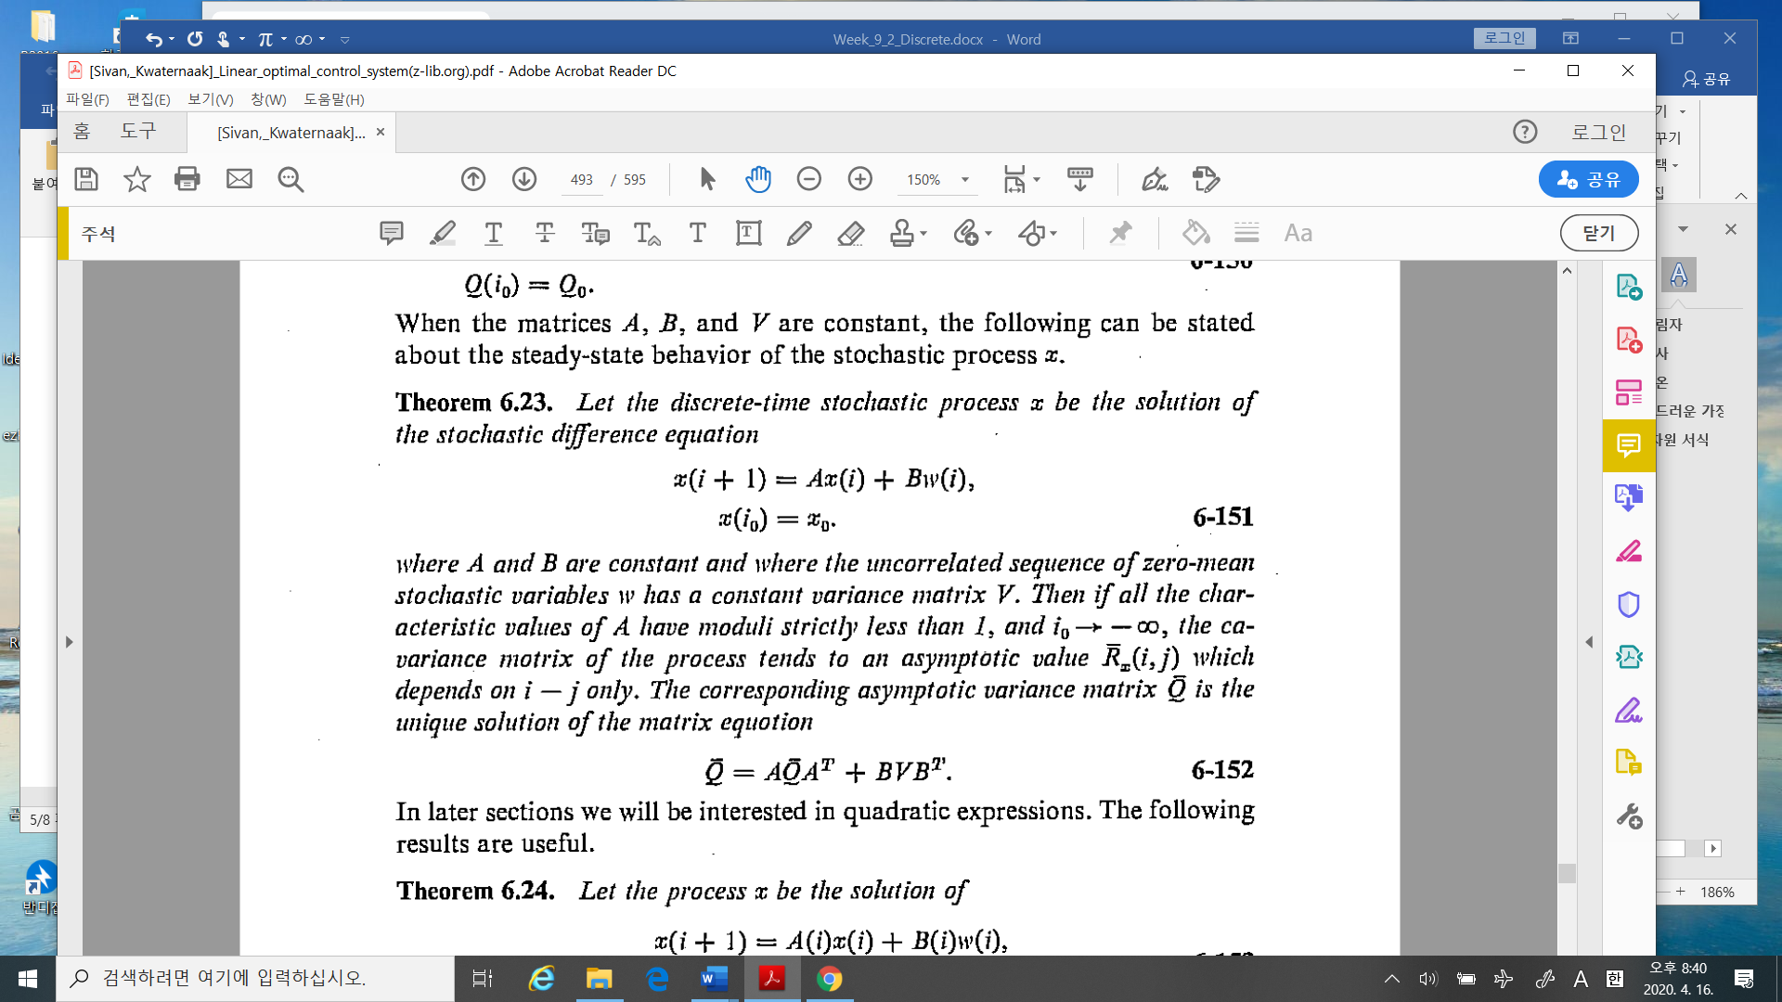

%%%%%%%%%%%------------- comments

In the continuous time case, i.e.,

$$\dot{x}=Ax+bw, E\left[ww^{T}\right]=V$$

Then the variance $Q\left(t\right)=E\left[\left[x\left(t\right)-m(t)\right]{\left[x\left(t\right)-m\left(t\right)\right]}^{T}\right]$ is the solution of a Lyapunov equation, i.e., by

$\dot{Q}=AQ+QA^{T}+BVB^{T} (1-502)$

Also in the steady state is

$0 =AQ+QA^{T}+BVB^{T} (1-502.1 )$

So the variances of the continuous and discrete time system are governed by the different form.

Why is this happened?

--------------------------%%%%%%%%%%%%%%%%

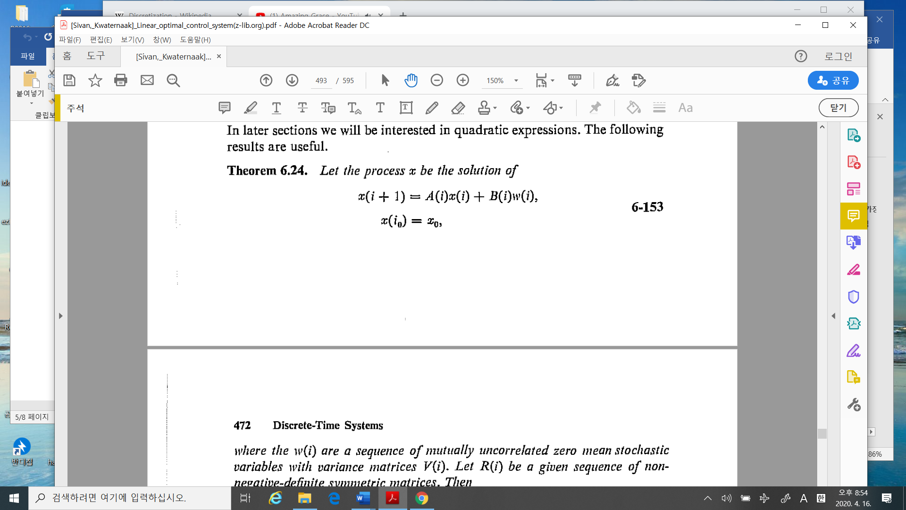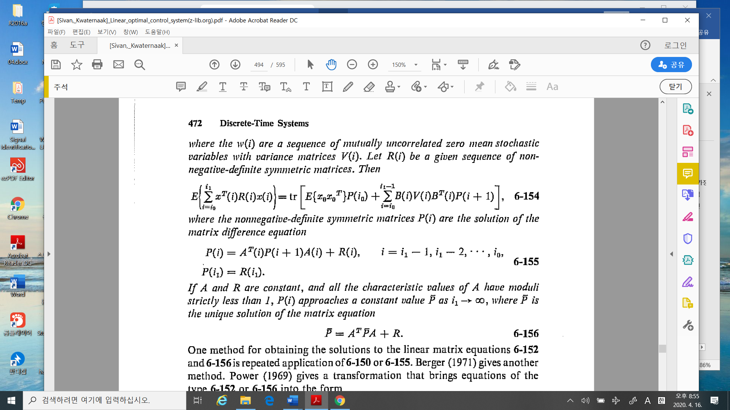

%%%%%%%%%%%%%%%-----------comments

This is the first step to design the optimal stochastic controller. In (6-154), (6-155), the “P” has the difference equation, but “Backward”!!

Next material we are considering the Optimal controller in stochastic linear system

--------------------------------------------------%%%%%%%%%%%%%%%%%